**PAST SIMPLE vs.**

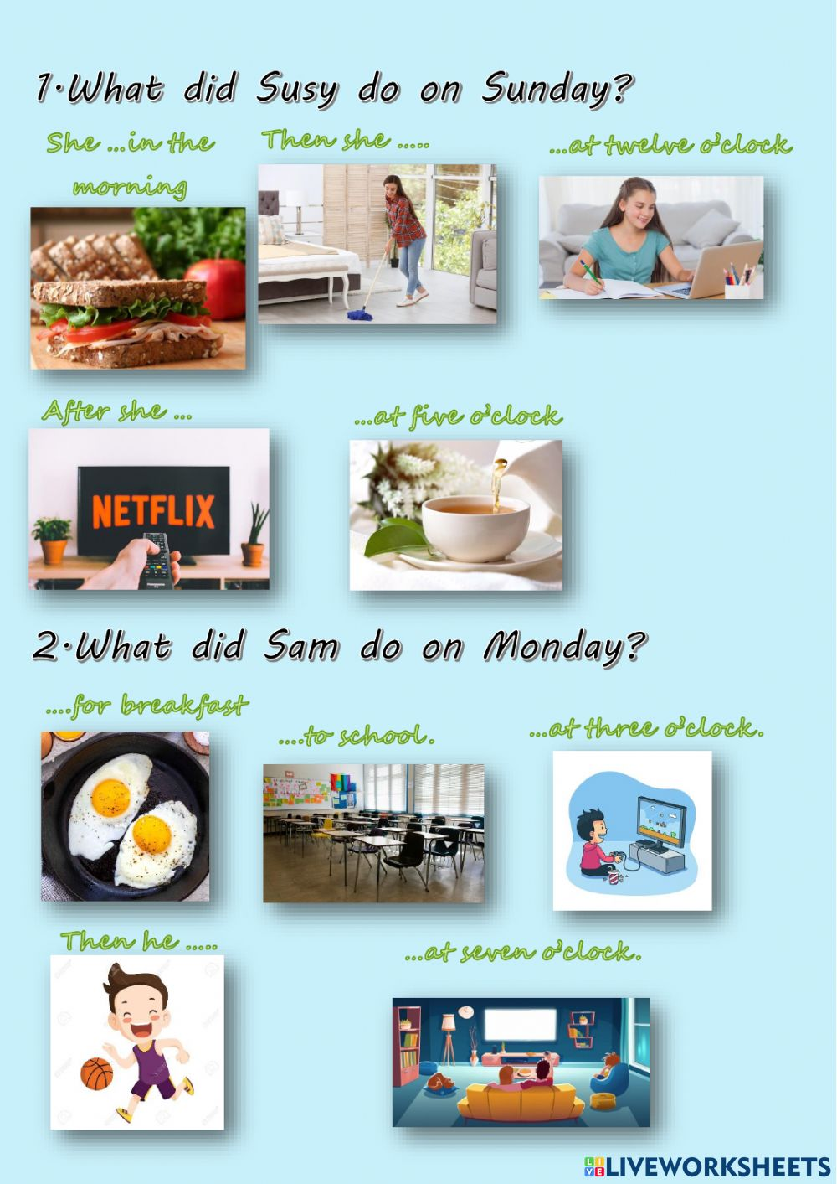

**PAST CONTINUOUS**

